TRIBHUVAN UNIVERSITY
PATAN MULTIPLE CAMPUS
PATANDHOKA, LALITPUR

NET CENTRIC COMPUTING (BIT 351)

SUBMITTED BY: | SUBMITTED TO:
NAME: SURESH DAHAL | SUBASH PARIYAR
ROLL: 23
CLASS: BIT-III/II | ___________________
DATE: 2083/04/22 | CHECKED BY

1. Introduction to .NET Framework
THEORY:
The .NET Framework is a software platform developed by Microsoft used for building and running applications on Windows. It provides a managed execution environment called the Common Language Runtime (CLR) and a massive collection of prebuilt classes called the Framework Class Library (FCL). Developers rely on these components, so they don't have to write low-level code for memory management, security, or type checking.
Key architectural components include:
- CLR (Common Language Runtime): Executes code and manages memory via Garbage Collection (GC).
- FCL (Framework Class Library): A rich library of classes (like System.IO or System.Console) ready for use.
- CTS (Common Type System): Establishes universal rules for data types across all .NET languages.
- CLS (Common Language Specification): Ensures that code written in different languages (like C#, VB.NET, or F#) can seamlessly interoperate and call each other.

PROGRAM:
using System;
class Assignment1
{
static void Main()
{
Console.WriteLine("Name: John Doe");
Console.WriteLine("Current Date & Time: " + DateTime.Now);
Console.WriteLine("CLR Version: " + Environment.Version);
}
}
OUTPUT:
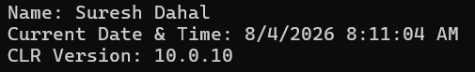

2. Compilation and Execution of .NET Applications
THEORY:
.NET applications use a unique two-step compilation process to achieve platform neutrality and execution efficiency.
- Source Code to MSIL: When you compile C# source code, the compiler (such as csc.exe) translates it into MSIL (Microsoft Intermediate Language) and metadata, rather than native machine code. MSIL is a CPU-independent instruction set.
- JIT Compilation to Native Code: At runtime, the Common Language Runtime (CLR) loads the MSIL assembly. The JIT (Just-In-Time) compiler then converts the MSIL into native machine-specific code right before execution.
Types of JIT compilers include Pre-JIT (compiles everything at load time), Econo-JIT (compiles methods on demand and discards them), and Normal JIT (compiles methods when called and caches them for reuse during execution).

PROGRAM:
using System;
class HelloWorldStages
{
static void Main()
{
Console.WriteLine("=== .NET Compilation & Execution Stages ===");
// Stage 1
Console.WriteLine("Stage 1: Source Code");
// Stage 2
Console.WriteLine("Stage 2: MSIL (csc.exe compiles source code into Microsoft Intermediate Language)");
// Stage 3
Console.WriteLine("Stage 3: CLR Loading (Common Language Runtime loads the assembly)");
// Stage 4
Console.WriteLine("Stage 4: JIT Compilation (Just-In-Time compiler converts MSIL to native machine code)");
// Stage 5
Console.WriteLine("Stage 5: Execution (Native code executes on the CPU)");
Console.WriteLine("\nFinal Output: Suresh Dahal!");
}
}

OUTPUT:
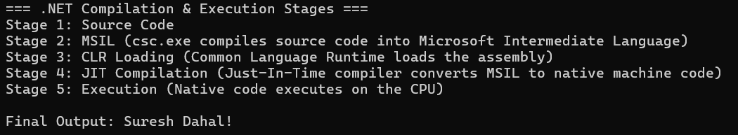

- Basic Language Constructs
THEORY:
Basic language constructs form the foundational syntax elements of C#, encompassing variable declarations, data types, operators, and control-flow statements used to write any program logic.
- Data Types: Categorized into Value Types (such as int, float, double, char, bool, struct, enum) which are stored directly on the stack, and Reference Types (such as string, class, array, object, interface) which store references to heap-allocated data.
- Operators: Include arithmetic, relational, logical, assignment, and bitwise operators.
- Control Flow: Consists of selection statements (if, switch) and iteration statements (for, while, do-while, foreach) to govern execution paths.

PROGRAM:
using System;

class PrimeCheck
{
static void Main()
{
Console.Write("Enter a number: ");
int num = Convert.ToInt32(Console.ReadLine());
bool isPrime = true;

if (num <= 1)
{
isPrime = false;
}
else
{
for (int i = 2; i <= Math.Sqrt(num); i++)
{
if (num % i == 0)
{
isPrime = false;
break;
}
}
}

Console.WriteLine(isPrime ? $"{num} is Prime" : $"{num} is Not Prime");
Console.WriteLine("Suresh Dahal - 23");
}
}
OUTPUT:
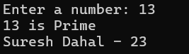

- Constructor
THEORY:
A constructor is a special member method that is automatically invoked when an object of a class is instantiated. It shares the exact name of the class, has no return type (not even void), and is primarily used to initialize object fields.
Types of constructors include:
- Default Constructor: Takes no parameters and initializes fields with default values.
- Parameterized Constructor: Accepts arguments to initialize fields with custom values.
- Copy Constructor: Initializes a new object using the values from an existing object of the same class.
- Static Constructor: Used to initialize static/shared data exactly once and runs automatically before any instance is created.
- Private Constructor: Prevents external instantiation of a class

PROGRAM:
using System;

class BankAccount
{
public string AccountHolder;
public double Balance;
public static int AccountCount = 0;

// Default Constructor
public BankAccount()
{
AccountHolder = "N/A";
Balance = 0;
AccountCount++;
}

// Parameterized Constructor
public BankAccount(string holder, double balance)
{
AccountHolder = holder;
Balance = balance;
AccountCount++;
}

// Copy Constructor
public BankAccount(BankAccount other)
{
AccountHolder = other.AccountHolder;
Balance = other.Balance;
AccountCount++;
}

public void Show() => Console.WriteLine($"{AccountHolder}: Rs. {Balance}");
}

class Program
{
static void Main()
{
BankAccount a1 = new BankAccount("Suresh", 3000);
BankAccount a2 = new BankAccount(a1); // Copy constructor usage

a1.Show();
a2.Show();
Console.WriteLine("Total Accounts: " + BankAccount.AccountCount);
Console.WriteLine("Suresh Dahal - 23");
}
}

OUTPUT:
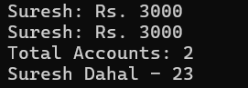

5. Properties
THEORY:
Properties in C# provide a secure, controlled mechanism to expose private fields to the outside world. They support the core object-oriented principle of encapsulation while letting callers interact with them as if they were standard public fields.
- Accessors: A property consists of a get accessor (to retrieve the value) and a set accessor (to assign a value). Inside a set accessor, the keyword value represents the data being assigned.
- Types of Properties: Read-Write (has both get and set), Read-Only (only get, no set), Write-Only (only set, no get), Auto-Implemented properties (where the compiler automatically generates the hidden backing field), and Computed properties (which return a calculated value without a dedicated backing field).

PROGRAM:
using System;

class Employee
{
private string name;
private double salary;

// 1. Read-Write Property with Validation
public string Name
{
get { return name; }
set { name = string.IsNullOrWhiteSpace(value) ? "Unknown" : value; }
}

// 2. Read-Write Property with Range Check
public double Salary
{
get { return salary; }
set { salary = value < 0 ? 0 : value; }
}

// 3. Computed Read-Only Property
public double AnnualSalary => salary * 12;
}

class Program
{
static void Main()
{
Employee emp = new Employee();

// Testing write accessor and validation
emp.Name = "Suresh Dahal";
emp.Salary = 50000;

// Testing read accessor and computed property
Console.WriteLine($"Name: {emp.Name}");
Console.WriteLine($"Monthly Salary: {emp.Salary}");
Console.WriteLine($"Annual Salary (Computed): {emp.AnnualSalary}");

// Testing invalid input rejection
emp.Salary = -1000;
Console.WriteLine($"After invalid assignment - Salary: {emp.Salary}, Annual: {emp.AnnualSalary}");
}
}

OUTPUT:
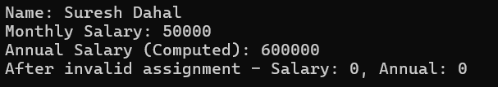

6. Arrays and Strings
THEORY:
Arrays and strings are fundamental data structures in C# used to manage collections of data and text respectively.
Key concepts include:
- Arrays: Fixed-size, zero-indexed collections that store multiple elements of the same data type in contiguous blocks of memory. They can be single-dimensional, multi-dimensional (rectangles like matrices), or jagged (arrays of arrays).
- Strings: Immutable sequences of characters representing text (System.String). Because they are immutable, any modification (such as concatenation or replacement) creates an entirely new object in memory.
- StringBuilder: A mutable alternative located in System.Text designed for heavy string manipulations inside loops, avoiding performance overhead and memory allocation issues caused by immutable string modifications.

PROGRAM:
using System;
using System.Text;

class Program
{
static void Main()
{
// 1. Array declaration and iteration
string[] subjects = { "net centric", "web tech", "database" };
int[] marks = { 85, 90, 78 };

Console.WriteLine("--- Array Elements ---");
for (int i = 0; i < subjects.Length; i++)
{
Console.WriteLine($"{subjects[i]}: {marks[i]}");
}

// 2. String manipulation
string title = " C# Programming Lab ";
string trimmed = title.Trim();
string upper = trimmed.ToUpper();
Console.WriteLine($"\nOriginal: '{title}'");
Console.WriteLine($"Processed String: {upper}");

// 3. StringBuilder usage for efficient string building
StringBuilder sb = new StringBuilder();
sb.Append("Status: ");
sb.Append("All ");
sb.Append(subjects.Length);
sb.Append(" subjects processed successfully.");

Console.WriteLine($"\n{sb.ToString()}");
Console.WriteLine("Suresh Dahal - 23");

}
}

OUTPUT:
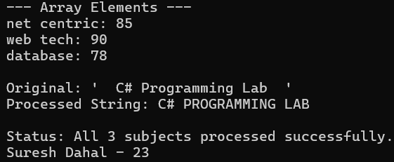

7. Indexers
THEORY:
Theory
An indexer allows instances of a class to be accessed using array-like syntax (obj[index]), implemented using the this keyword with get/set accessors.
- Single-parameter indexer: Indexed by one value, such as an integer.
- Multi-parameter indexer: Indexed by multiple values, such as obj[row, col].
- Overloaded indexer: Multiple indexers with different parameter types (e.g., int and string).
- Use: Makes custom classes behave like arrays or collections, useful for wrapper classes around internal data structures, and improves code readability.

PROGRAM:
using System;

class TemperatureLog
{
private double[] temperatures = new double[7];

public double this[int index]
{
get
{
if (index >= 0 && index < 7)
return temperatures[index];
else
throw new IndexOutOfRangeException("Invalid day index!");
}

set
{
if (index >= 0 && index < 7)
temperatures[index] = value;
else
throw new IndexOutOfRangeException("Invalid day index!");
}
}
}

class Program
{
static void Main()
{
TemperatureLog log = new TemperatureLog();

for (int i = 0; i < 7; i++)
{
Console.Write("Enter temperature for day " + i + ": ");
log[i] = Convert.ToDouble(Console.ReadLine());
}

Console.WriteLine("\nTemperature Record:");
for (int i = 0; i < 7; i++)
{
Console.WriteLine("Day " + i + ": " + log[i] + "°C");
}
Console.WriteLine("Suresh Dahal - 23");
}
}

OUTPUT:
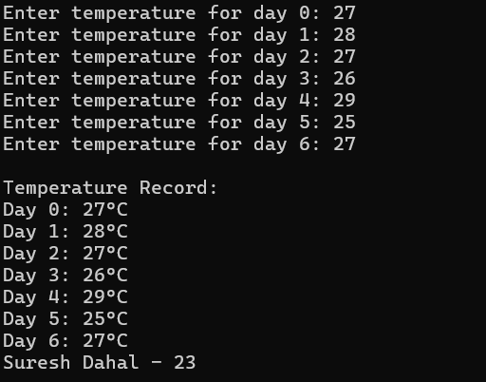

8. Inheritance and the base Keyword
THEORY:
Inheritance is an object-oriented programming concept that allows one class (derived class) to inherit the properties and methods of another class (base class). It promotes code reusability and establishes an "is-a" relationship between classes. The base keyword is used in a derived class to access members (fields, properties, methods, or constructors) of the base class. It is commonly used when extending the functionality of an inherited method instead of completely replacing it.
PROGRAM:
using System;

class Vehicle
{
public string Brand;

public Vehicle(string brand)
{
Brand = brand;
}

public virtual void Start()
{
Console.WriteLine(Brand + " vehicle is starting.");
}
}

class Car : Vehicle
{
public int NumberOfDoors;

public Car(string brand, int doors) : base(brand)
{
NumberOfDoors = doors;
}

public override void Start()
{
base.Start();
Console.WriteLine("Car has " + NumberOfDoors + " doors.");
}
}

class Program
{
static void Main()
{
Car car = new Car("Mustang", 4);

car.Start();

Console.WriteLine("Suresh Dahal - 23");
}
}

OUTPUT:
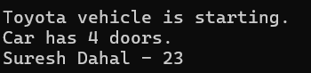

9. Method Hiding and Overriding
THEORY:
Method overriding allows a derived class to provide a new implementation of a virtual method defined in the base class. It enables runtime polymorphism, where the method called depends on the actual object type.
Method hiding is achieved using the new keyword, which hides a non-virtual method of the base class. Unlike overriding, method hiding depends on the reference type rather than the object type. When a derived object is accessed through a base class reference, overridden methods execute the derived version, while hidden methods execute the base version.
PROGRAM:
using System;

class Employee
{
public virtual void CalculateBonus()
{
Console.WriteLine("Employee Bonus: Rs. 5,000");
}

public void PrintPolicy()
{
Console.WriteLine("Employee Leave Policy");
}
}

class Manager : Employee
{
public override void CalculateBonus()
{
Console.WriteLine("Manager Bonus: Rs. 15,000");
}

public new void PrintPolicy()
{
Console.WriteLine("Manager Leave Policy");
}
}

class Program
{
static void Main()
{
Employee emp = new Manager();

emp.CalculateBonus(); // Overridden method
emp.PrintPolicy(); // Hidden method

Console.WriteLine();

Manager mgr = new Manager();
mgr.CalculateBonus();
mgr.PrintPolicy();

Console.WriteLine("Suresh Dahal - 23");
}
}

OUTPUT:
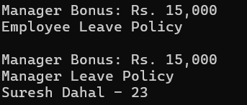

10. Applying Polymorphism in Code Extensibility
THEORY:
Polymorphism allows objects of different classes to be treated as objects of a common base class. It enables the same method call to produce different behaviors depending on the object's actual type. This makes programs more flexible, extensible, and easier to maintain. In C#, polymorphism is commonly achieved using abstract classes or interfaces. New derived classes can be added without modifying existing code, following the Open/Closed Principle.
PROGRAM:
using System;
using System.Collections.Generic;

abstract class PaymentMethod
{
public abstract void Pay(double amount);
}

class CreditCardPayment : PaymentMethod
{
public override void Pay(double amount)
{
Console.WriteLine("Paid Rs. " + amount + " using Credit Card.");
}
}

class CashPayment : PaymentMethod
{
public override void Pay(double amount)
{
Console.WriteLine("Paid Rs. " + amount + " in Cash.");
}
}

class MobileWalletPayment : PaymentMethod
{
public override void Pay(double amount)
{
Console.WriteLine("Paid Rs. " + amount + " using Mobile Wallet.");
}
}

class Program
{
static void Main()
{
List<PaymentMethod> payments = new List<PaymentMethod>()
{
new CreditCardPayment(),
new CashPayment(),
new MobileWalletPayment()
};

foreach (PaymentMethod payment in payments)
{
payment.Pay(3000);
}

Console.WriteLine("Suresh Dahal - 23");
}
}

OUTPUT:
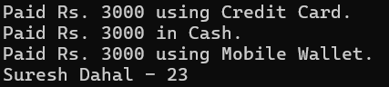

11. Structs and Enums
THEORY:
A struct is a value type in C# used to store small and lightweight data objects. Unlike classes, structs are stored on the stack (in most cases) and do not support inheritance. They are suitable for representing simple data such as points, dates, or complex numbers. An enum (enumeration) is a user-defined type that represents a set of named constants, making code more readable and reducing the use of numeric values. Structs and enums are commonly used together to organize and simplify programs.
PROGRAM:
using System;

struct Complex
{
public double Real;
public double Imaginary;

public Complex(double real, double imaginary)
{
Real = real;
Imaginary = imaginary;
}

public Complex Add(Complex c)
{
return new Complex(Real + c.Real, Imaginary + c.Imaginary);
}

public void Display()
{
Console.WriteLine(Real + " + " + Imaginary + "i");
}
}

enum Operation
{
Add,
Subtract,
Multiply,
Divide
}

class Program
{
static void Main()
{
Complex c1 = new Complex(2, 3);
Complex c2 = new Complex(4, 5);

Complex result = c1.Add(c2);

Console.Write("Sum of Complex Numbers: ");
result.Display();

int a = 10, b = 5;
Operation op = Operation.Multiply;

switch (op)
{
case Operation.Add:
Console.WriteLine("Addition: " + (a + b));
break;

case Operation.Subtract:
Console.WriteLine("Subtraction: " + (a - b));
break;

case Operation.Multiply:
Console.WriteLine("Multiplication: " + (a * b));
break;

case Operation.Divide:
Console.WriteLine("Division: " + (a / b));
break;
}
}
}
OUTPUT:
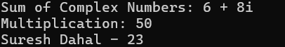
12. Abstract Class and Sealed Class
THEORY:
An abstract class is a class that cannot be instantiated directly. It is used as a base class and can contain both abstract methods (without implementation) and concrete methods (with implementation). Derived classes must provide implementations for all abstract methods.
A sealed class is a class that cannot be inherited by any other class. It is used when further inheritance should be restricted to improve security and maintain the intended behavior of the class.
PROGRAM:
using System;

abstract class Employee
{
public string Name;
public double BasicSalary;

public Employee(string name, double salary)
{
Name = name;
BasicSalary = salary;
}

public abstract double CalculateSalary();

public void DisplayDetails()
{
Console.WriteLine("Name: " + Name);
Console.WriteLine("Salary: Rs. " + CalculateSalary());
}
}

class PermanentEmployee : Employee
{
public PermanentEmployee(string name, double salary)
: base(name, salary)
{
}

public override double CalculateSalary()
{
return BasicSalary + 5000;
}
}

sealed class ContractEmployee : Employee
{
public ContractEmployee(string name, double salary)
: base(name, salary)
{
}

public override double CalculateSalary()
{
return BasicSalary;
}
}

class Program
{
static void Main()
{
Employee emp1 = new PermanentEmployee("Suresh", 30000);
Employee emp2 = new ContractEmployee("Luna", 25000);

emp1.DisplayDetails();
Console.WriteLine();

emp2.DisplayDetails();
}
}

OUTPUT:
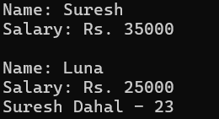

13. Interface
THEORY:
An interface is a reference type in C# that defines a contract containing method declarations without implementation. A class that implements an interface must provide implementations for all its methods. Unlike classes, a class can implement multiple interfaces, making interfaces a useful way to achieve multiple inheritance in C#. They also support polymorphism, allowing objects of different classes to be accessed through interface references.
PROGRAM:
using System;

interface IMovable
{
void Move();
}

interface IFlyable
{
void Fly();
}

class Bird : IMovable, IFlyable
{
public void Move()
{
Console.WriteLine("Bird is moving.");
}

public void Fly()
{
Console.WriteLine("Bird is flying.");
}
}

class Car : IMovable
{
public void Move()
{
Console.WriteLine("Car is moving.");
}
}

class Program
{
static void Main()
{
IMovable movable;

movable = new Bird();
movable.Move();

movable = new Car();
movable.Move();

IFlyable flyable = new Bird();
flyable.Fly();

Console.WriteLine("Suresh Dahal - 23");
}
}

OUTPUT:
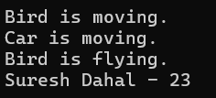
14. Delegate and Events
THEORY:
A delegate is a type-safe reference that can point to one or more methods with the same signature. It is commonly used to implement events, which allow one object (publisher) to notify other objects (subscribers) when a particular action occurs. Events follow the publisher-subscriber model, where multiple subscribers can respond to the same event independently. This makes programs more flexible and loosely coupled.
PROGRAM:
using System;

class Alarm
{
public delegate void AlarmHandler();
public event AlarmHandler OnAlarmTriggered;

public void Trigger()
{
Console.WriteLine("Alarm Triggered!");
OnAlarmTriggered?.Invoke();
}
}

class Logger
{
public void LogAlarm()
{
Console.WriteLine("Logging alarm to system.");
}
}

class Notifier
{
public void SendNotification()
{
Console.WriteLine("Sending notification to user.");
}
}

class Program
{
static void Main()
{
Alarm alarm = new Alarm();
Logger logger = new Logger();
Notifier notifier = new Notifier();

alarm.OnAlarmTriggered += logger.LogAlarm;
alarm.OnAlarmTriggered += notifier.SendNotification;

alarm.Trigger();
}
}
OUTPUT:
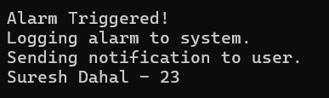

15. Partial Class
THEORY:
A partial class allows the definition of a single class to be split across multiple files or sections using the partial keyword. During compilation, the C# compiler combines all the partial definitions into one complete class. Partial classes improve code organization, especially in large projects where different developers work on different parts of the same class or when code is automatically generated by tools such as Visual Studio.

PROGRAM:
using System;

// Part 1
partial class Car
{
public string Model;
public int Year;
}

// Part 2
partial class Car
{
public string EngineType;
public int HorsePower;

public void Display()
{
Console.WriteLine("Model: " + Model);
Console.WriteLine("Year: " + Year);
Console.WriteLine("Engine Type: " + EngineType);
Console.WriteLine("Horse Power: " + HorsePower);
}
}

class Program
{
static void Main()
{
Car car = new Car();

car.Model = "Toyota Hilux";
car.Year = 2023;
car.EngineType = "Petrol";
car.HorsePower = 169;

car.Display();

Console.WriteLine("Suresh Dahal");
}
}

OUTPUT:
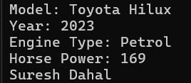

16. Collections
THEORY:
Collections in C# are classes used to store and manage groups of objects efficiently. The Dictionary<TKey, TValue> collection stores data as key-value pairs, allowing fast searching using a unique key. The Queue<T> collection follows the FIFO (First In, First Out) principle, where the first element added is the first one removed. Generic collections, available in the System.Collections.Generic namespace, provide type safety and better performance than non-generic collections.
PROGRAM:
using System;
using System.Collections.Generic;

class Program
{
static void Main()
{
// Contact Book using Dictionary
Dictionary<string, string> contacts = new Dictionary<string, string>();

contacts.Add("Suresh", "9800000001");
contacts.Add("Luna", "9800000002");
contacts.Add("Hari", "9800000003");

Console.WriteLine("Searching for Suresh:");
if (contacts.ContainsKey("Suresh"))
Console.WriteLine("Phone: " + contacts["Suresh"]);

contacts.Remove("Hari");

Console.WriteLine("\nContact List:");
foreach (var contact in contacts)
{
Console.WriteLine(contact.Key + " : " + contact.Value);
}

// Customer Ticket System using Queue
Queue<string> tickets = new Queue<string>();

tickets.Enqueue("Ticket 101");
tickets.Enqueue("Ticket 102");
tickets.Enqueue("Ticket 103");

Console.WriteLine("\nServing: " + tickets.Dequeue());

Console.WriteLine("Remaining Tickets:");
foreach (string ticket in tickets)
{
Console.WriteLine(ticket);
}

Console.WriteLine("Suresh Dahal - 23");
}
}

OUTPUT:
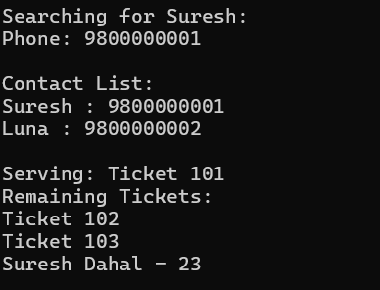

17. Generics
THEORY:
Generics allow classes and methods to work with different data types while maintaining type safety. Instead of writing separate code for each data type, a generic class or method uses type parameters such as T, T1, and T2. This reduces code duplication, improves reusability, and eliminates the need for type casting. Generic methods can also use constraints, such as where T : IComparable<T>, to ensure that the type supports specific operations like comparison.
PROGRAM:
using System;

class Pair<T1, T2>
{
public T1 First;
public T2 Second;

public Pair(T1 first, T2 second)
{
First = first;
Second = second;
}

public void Display()
{
Console.WriteLine("First: " + First);
Console.WriteLine("Second: " + Second);
}
}

class Program
{
static T FindMax<T>(T a, T b) where T : IComparable<T>
{
if (a.CompareTo(b) > 0)
return a;
else
return b;
}

static void Main()
{
Pair<string, int> student = new Pair<string, int>("Ram", 85);
student.Display();

Console.WriteLine("\nMaximum: " + FindMax(25, 40));

Console.WriteLine("Suresh Dahal - 23");
}
}

OUTPUT:
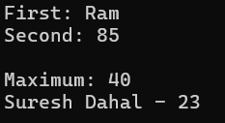

18. File I/O
THEORY:
File I/O (Input/Output) in C# is used to read from and write data to files. The System.IO namespace provides classes such as StreamWriter and StreamReader for handling text files. File I/O allows data to be stored permanently so it can be accessed even after the program ends. It is commonly used for saving records, reports, logs, and configuration data.
PROGRAM:
using System;
using System.IO;

class Program
{
static void Main()
{
string fileName = "records.txt";

StreamWriter writer = new StreamWriter(fileName);

double total = 0;

for (int i = 1; i <= 3; i++)
{
Console.Write("Enter student name: ");
string name = Console.ReadLine();

Console.Write("Enter marks: ");
double marks = Convert.ToDouble(Console.ReadLine());

writer.WriteLine(name + "," + marks);
total += marks;
}

writer.Close();

Console.WriteLine("\nStudent Records:");
StreamReader reader = new StreamReader(fileName);

string line;
while ((line = reader.ReadLine()) != null)
{
Console.WriteLine(line);
}

reader.Close();

Console.WriteLine("\nAverage Marks: " + (total / 3));
}
}

OUTPUT:
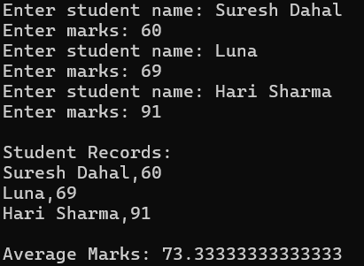

19. LINQ Fundamentals: Lambda Expressions
THEORY:
LINQ (Language Integrated Query) is a feature in C# that allows querying and manipulating data from collections, arrays, databases, and XML using a consistent syntax. Lambda expressions are short anonymous functions used with LINQ methods such as Where(), OrderByDescending(), Average(), and First(). They make code concise, readable, and easy to maintain by eliminating the need for complex loops.
PROGRAM:
using System;
using System.Collections.Generic;
using System.Linq;

class Student
{
public string Name { get; set; }
public int Marks { get; set; }
}

class Program
{
static void Main()
{
List<Student> students = new List<Student>
{
new Student { Name = "Ram", Marks = 80 },
new Student { Name = "Sita", Marks = 92 },
new Student { Name = "Hari", Marks = 68 },
new Student { Name = "Gita", Marks = 85 }
};

var passed = students.Where(s => s.Marks > 75);

var sorted = students.OrderByDescending(s => s.Marks);

double average = students.Average(s => s.Marks);

string topper = students
.OrderByDescending(s => s.Marks)
.First().Name;

Console.WriteLine("Students scoring above 75:");
foreach (var s in passed)
{
Console.WriteLine(s.Name + " - " + s.Marks);
}

Console.WriteLine("\nSorted by Marks:");
foreach (var s in sorted)
{
Console.WriteLine(s.Name + " - " + s.Marks);
}

Console.WriteLine("\nAverage Marks: " + average);
Console.WriteLine("Topper: " + topper);

Console.WriteLine("Suresh Dahal - 23");
}
}

OUTPUT:
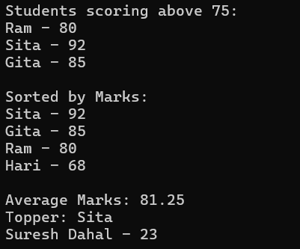
20. Try Statements and Exceptions
THEORY:
Exception handling is used to detect and manage runtime errors without terminating the program unexpectedly. In C#, the try block contains code that may throw an exception, while the catch block handles specific exceptions. Common exceptions include DivideByZeroException and FormatException. Developers can also create custom exceptions by inheriting from the Exception class to handle application-specific errors, improving program reliability and user experience.
PROGRAM:
using System;

class InvalidOperatorException : Exception
{
public InvalidOperatorException(string message) : base(message)
{
}
}

class Program
{
static void Main()
{
try
{
Console.Write("Enter first number: ");
int num1 = Convert.ToInt32(Console.ReadLine());

Console.Write("Enter operator (+, -, *, /): ");
char op = Convert.ToChar(Console.ReadLine());

Console.Write("Enter second number: ");
int num2 = Convert.ToInt32(Console.ReadLine());

switch (op)
{
case '+':
Console.WriteLine("Result = " + (num1 + num2));
break;

case '-':
Console.WriteLine("Result = " + (num1 - num2));
break;

case '*':
Console.WriteLine("Result = " + (num1 * num2));
break;

case '/':
Console.WriteLine("Result = " + (num1 / num2));
break;

default:
throw new InvalidOperatorException("Invalid operator entered.");
}
}
catch (DivideByZeroException)
{
Console.WriteLine("Error: Cannot divide by zero.");
}
catch (FormatException)
{
Console.WriteLine("Error: Please enter valid numbers.");
}
catch (InvalidOperatorException ex)
{
Console.WriteLine("Error: " + ex.Message);
}

Console.WriteLine("Suresh Dahal - 23");
}
}

OUTPUT:
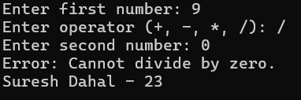

21. Attributes
THEORY:
Attributes in C# are used to add metadata (additional information) to program elements such as classes, methods, properties, and assemblies. They are declared by creating a class that inherits from the Attribute class. Attributes can store information such as the author's name, version, or review date. Using Reflection, a program can read these attributes at runtime, making them useful for documentation, validation, testing, and code analysis.
Types of Attribute Parameters
- Positional Parameters: Passed through the attribute constructor and are mandatory. They are specified first.
- Named Parameters: Specified using the property or field name (e.g., Name = value). They are optional and can be written in any order after positional parameters.

PROGRAM:
using System;
using System.Reflection;

[AttributeUsage(AttributeTargets.Method)]
class ReviewedAttribute : Attribute
{
public string ReviewerName { get; }
public string Date { get; set; }

public ReviewedAttribute(string reviewerName)
{
ReviewerName = reviewerName;
}
}

class Sample
{
[Reviewed("Suresh", Date = "2026-08-01")]
public void Method1()
{
}

[Reviewed("Luna", Date = "2026-08-02")]
public void Method2()
{
}
}

class Program
{
static void Main()
{
Type type = typeof(Sample);

foreach (MethodInfo method in type.GetMethods())
{
ReviewedAttribute attr =
(ReviewedAttribute)Attribute.GetCustomAttribute(
method, typeof(ReviewedAttribute));

if (attr != null)
{
Console.WriteLine("Method: " + method.Name);
Console.WriteLine("Reviewer: " + attr.ReviewerName);
Console.WriteLine("Date: " + attr.Date);
Console.WriteLine();
}
}

Console.WriteLine("Suresh Dahal - 23");
}
}

OUTPUT:
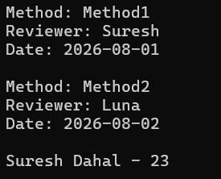

22. Asynchronous Programming
THEORY:
Asynchronous programming allows a program to perform multiple tasks without blocking the main thread. In C#, the async and await keywords are used with the Task class to execute asynchronous operations efficiently. Task.WhenAll() allows multiple tasks to run concurrently and waits until all of them complete. This improves application responsiveness and performance, especially for operations such as file handling, network communication, and database access.
PROGRAM:
using System;
using System.Threading.Tasks;

class Program
{
static async Task PrepareFoodAsync()
{
Console.WriteLine("Preparing food...");
await Task.Delay(3000);
Console.WriteLine("Food is ready.");
}

static async Task ArrangeDeliveryAsync()
{
Console.WriteLine("Arranging delivery...");
await Task.Delay(2000);
Console.WriteLine("Delivery partner assigned.");
}

static async Task DeliverOrderAsync()
{
Console.WriteLine("Order delivered successfully.");
await Task.CompletedTask;
}

static async Task Main()
{
try
{
await Task.WhenAll(
PrepareFoodAsync(),
ArrangeDeliveryAsync()
);

await DeliverOrderAsync();
}
catch (Exception ex)
{
Console.WriteLine("Error: " + ex.Message);
}

Console.WriteLine("Suresh Dahal - 23");
}
}

OUTPUT:
